  
Maliban Distribution System User guide

Program requirements

* Software:-
  + - Visual studio 2010
    - C# language
* Hardware:-
  + - Intel Dual core 2.6 GHz processor
    - 2GB Ram
    - 3 GB hard disk



[Guide on Inserting, searching, updating and deleting details]

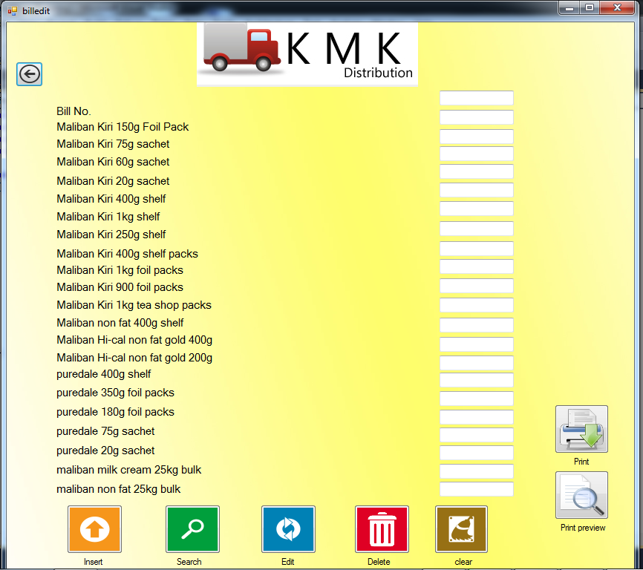

[Insert]

To insert any detail, type the required details to be inserted in textboxes and press Insert button (Number 1 button).This will save your data in data base and if inserting of the details was successful, a message box will pop up.

[Search]

To Search any inserted details, type the required Bill number in bill number textbox and press Search button (Number 2 button).This will Search the database and if it finds any details message box will popup and show the related details in the fields. If there is no record to show, a message box will pop up and say “No record found”.

[Update]

To update any details, type the Bill number that you are going to update and type the required details to be updated. After this press Update button (Number 3 button). This will update your record and if it was success full, message box will pop up saying Updated.

[Delete]

To delete a record simply add the required bill number to be deleted in the bill number textbox and press delete button (Number 4 button). This will delete your record permanently,

[Clear]

Clear will clean the every text box with any details.

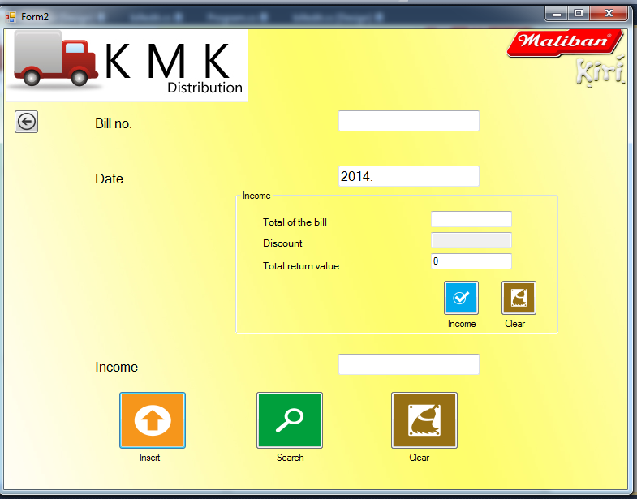

1. To enter the Income details of Daily Bills,
   * 1. Type the specific Bill number
     2. Type the data
     3. Total of the bill
     4. Total return value
     5. Press the Income button (Number 1 button)
     6. This will give the Income
2. To insert the values, press the insert Button
3. To search the date and Income of a certain Bill, Type the Bill number that required and press search button.